Expt:no:09 Map Coloring using Constraint Satisfaction Problem (CSP)
AIM
To write a Python program to solve the Map Coloring Problem using Constraint Satisfaction Problem (CSP) by assigning colors to different regions such that no two adjacent regions have the same color.
OBJECTIVES
- To represent the map as a graph of regions and their neighboring regions.
- To assign a set of possible colors to each region.
- To ensure that adjacent regions receive different colors.
- To use backtracking to find a valid color assignment.
- To demonstrate the application of Constraint Satisfaction Problems (CSP) in solving real-world problems.
ALGORITHM
- Start the program.
- Represent the map as a graph, where each region is a node and neighboring regions are connected by edges.
- Define a list of available colors.
- Select an unassigned region.
- Assign a color to the selected region.
- Check whether the assigned color conflicts with the colors of its neighboring regions.
- If there is no conflict, move to the next unassigned region.
- If a conflict occurs, try another available color.
- If no color is valid, backtrack to the previous region and change its color.
- Continue until all regions are successfully colored.
- Display the valid color assignment.
- Stop.

FLOW CHART:
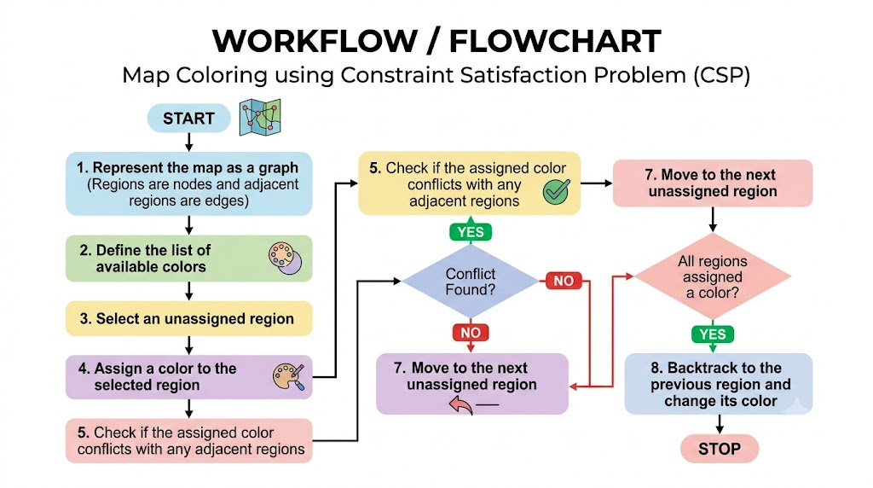

PYTHON CODE:
def color_map(graph, colors):
result = {}

def safe(node, color):
return all(result.get(n) != color for n in graph[node])

def backtrack():
if len(result) == len(graph):
return True
node = next(n for n in graph if n not in result)
for color in colors:
if safe(node, color):
result[node] = color
if backtrack():
return True
del result[node]
return False

return result if backtrack() else None

graph = {
"A": ["B", "C"], "B": ["A", "C", "D"],
"C": ["A", "B", "D"], "D": ["B", "C"]
}
print(color_map(graph, ["Red", "Green", "Blue"]))

OUTPUT:


RESULT:

The Python program successfully solves the Map Coloring problem using Constraint Satisfaction and Backtracking.

